# Automation Testing Framework

Type: TDD Framework

Data: using JSON/Properties files

Core programming language: Java

Reporting: Extent report with Listener class and iRetry mechanism

Unit Test: TestNG

Runner: TestNG.xml or custom xml files

Logging: Lombok plugin, SLF4J with log4j binding

Preffered IDE: IntelliJ ide

Design pattern: Used POM with PageFactory library

Test Scripts: Moduler design

Version control: GIT

Folder structure:

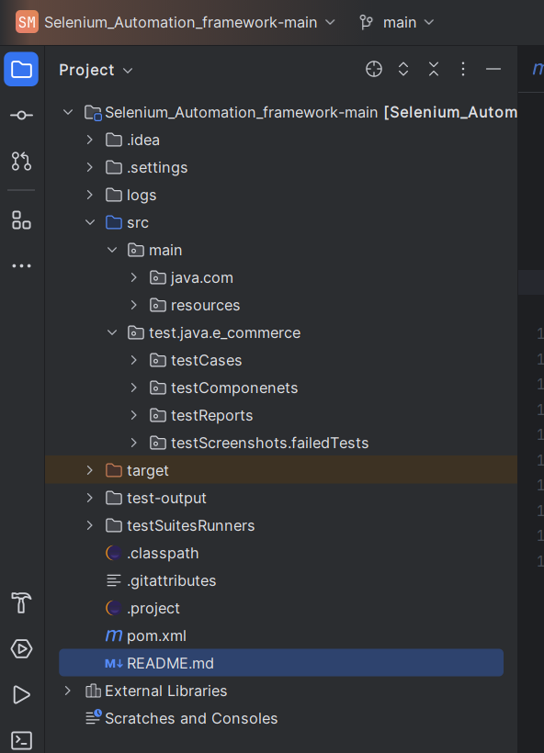 Here the main SRC folder has > main folder which contains the java > utils files and page object

Then main > resources folder > properties files and extent report setup class

The test > java > e_commerce folder has the following

-testCases - contains the test cases

-testCompontents - contains basetest, listener class, iretry class

-testReports - to generate a html extent report of the latest run

-testScreenshots- location to store failed test cases screenshots

Expaned view

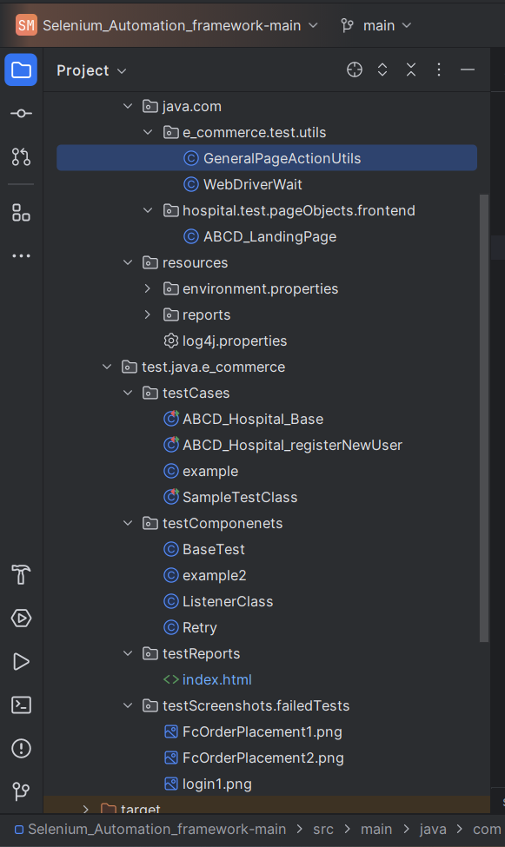

**How to run the project:**

1. Install IntelliJ - ignore if already you have (Eclipse has issue with Project folder setup, you can do this in eclipse to just make sure to update your build path and point to correct source folder )
2. Install testng, lombok plugin
3. Get a git pull in you local repo
4. Open the project and do mvn clean compile and then install so that your .m2 folder will be updated with the pom.xml dependencies
5. Build the project and check for any errors, try to resolve them they will mostly be configuration or folder structure issue.
6. Open the testSuiteRunner folder and run the ABCD_Hospital.xml as testNG suite
7. You will see the logs in your console and a file will get updated in the log folder of the project called application.log
8. Check the report in the src/test/java/e_commerce/testReports/index.html open it in browser.

Some project snipshot:

The remote browser is running:

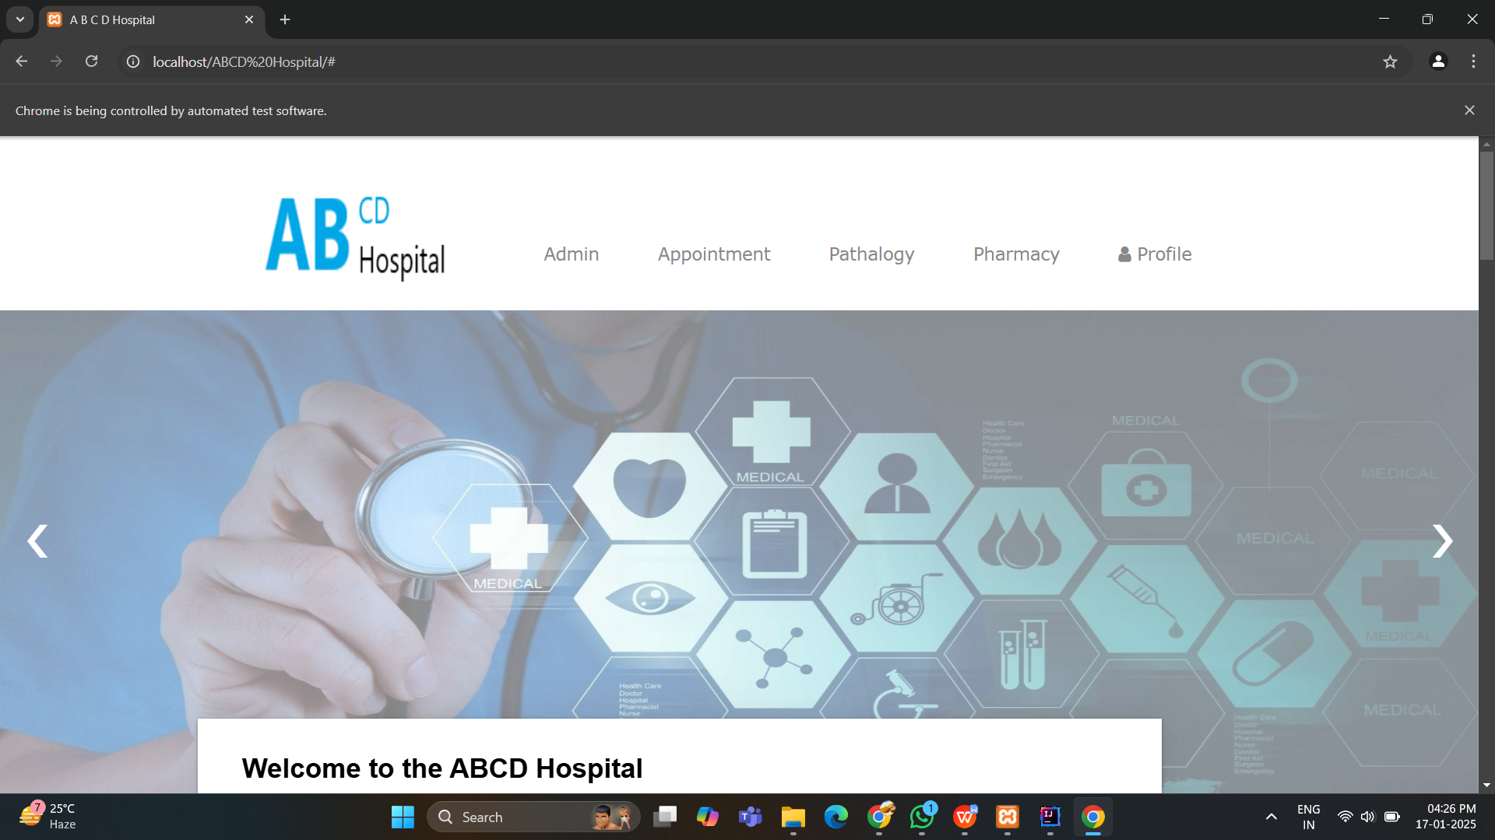

See logs are getting printed in the console

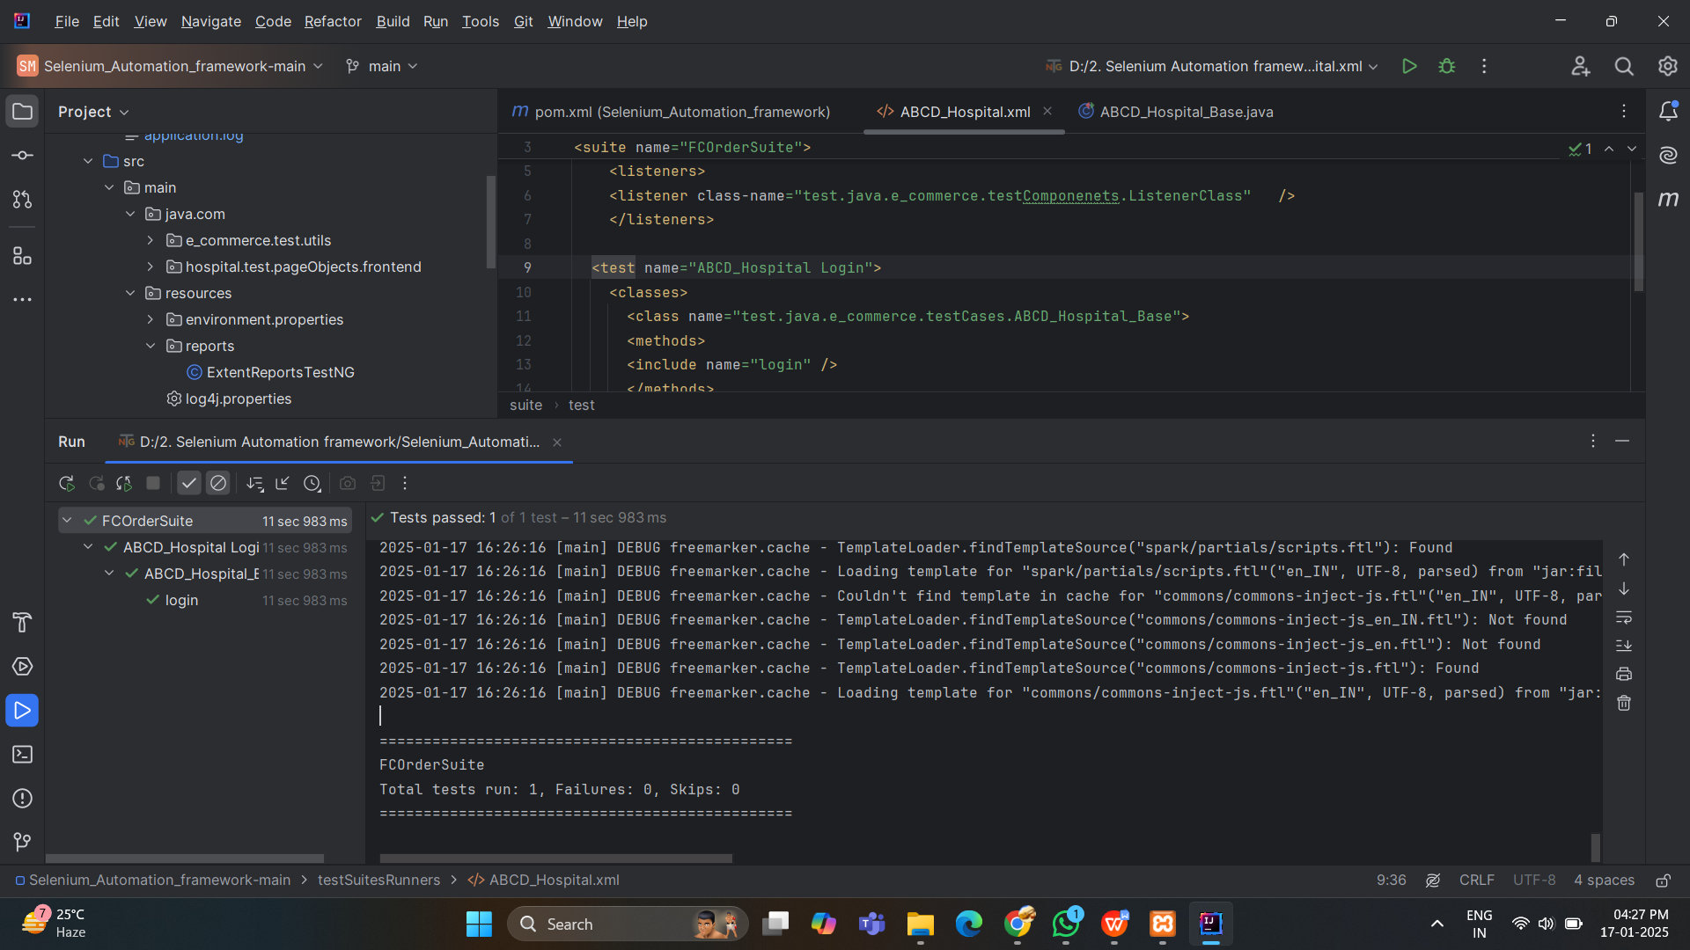

Check the application.log for log details

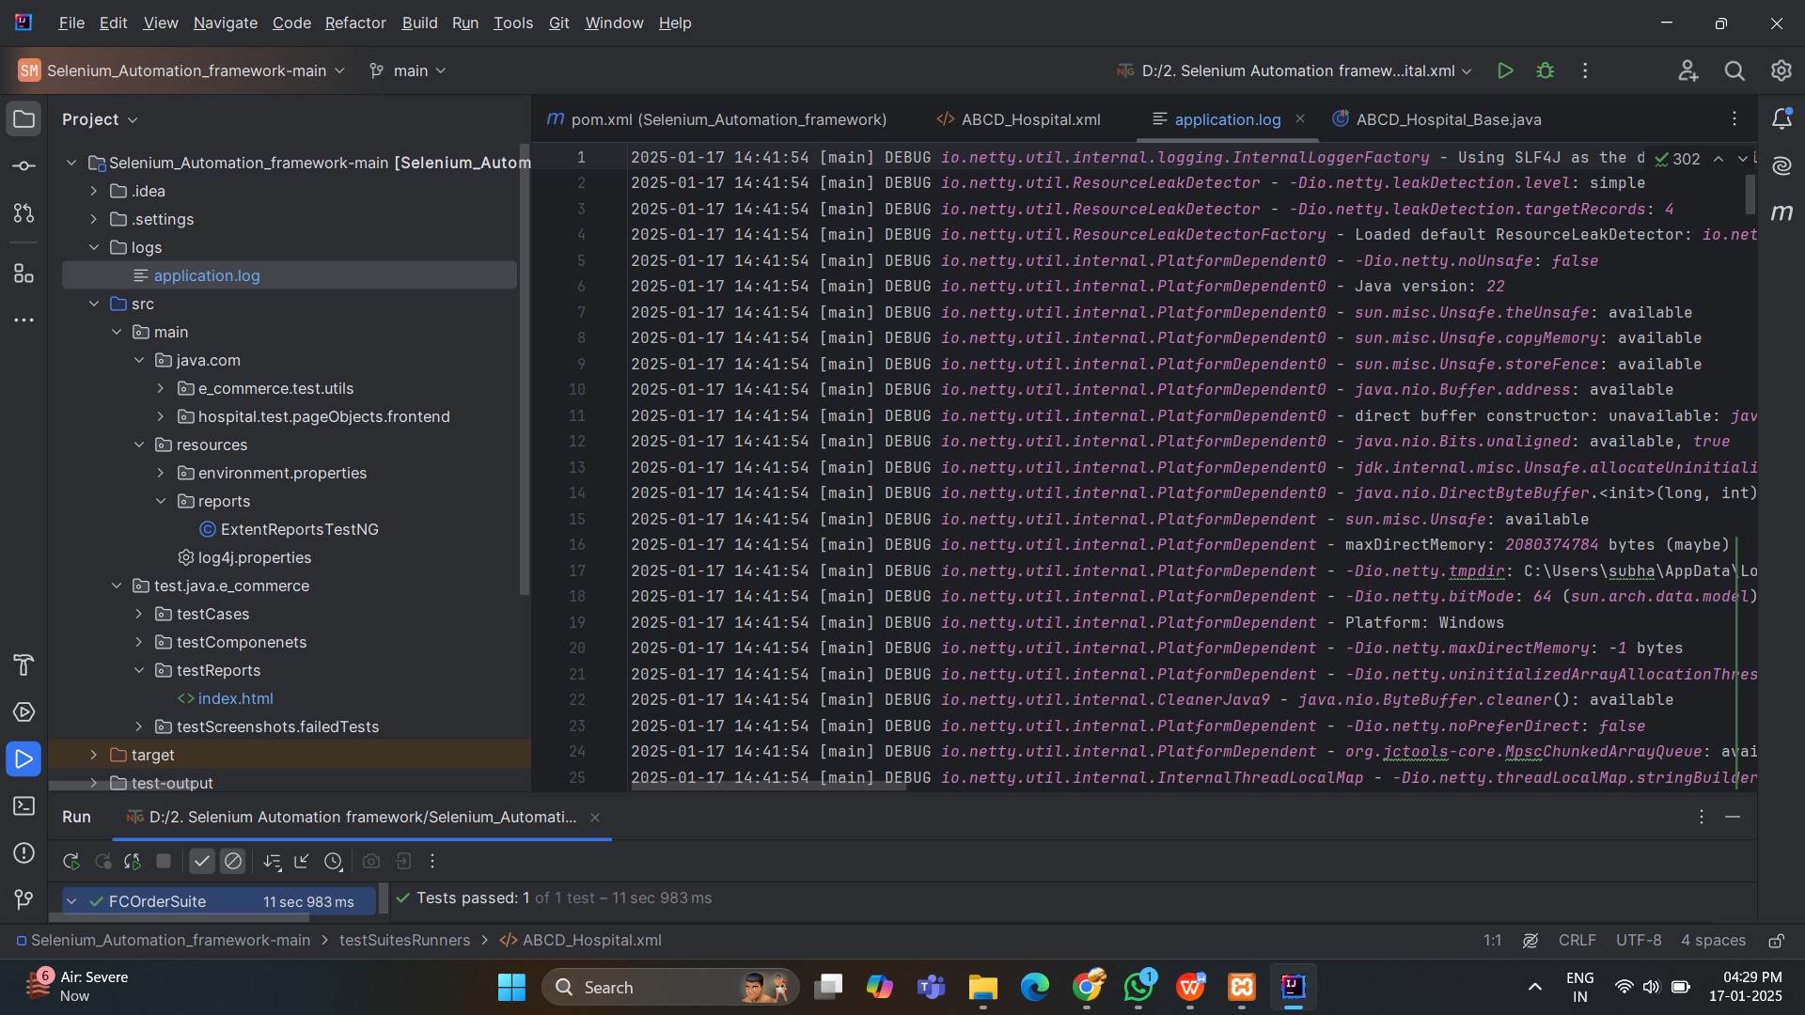

Report

